KONFIGURASI MULTIPLE PHP PADA VPS CENTOS7
1. Persiapan
Client1 | Client2
OS: Centos7 | OS: Centos7
IP: 117.53.44.123 | IP: 117.53.44.123
domain: client1.leon36.web.id | domain: clieent2.leon36.web.id
apache2 | apache2
php5.6 | php7.1
Wordpress | Joomla

2. Install paket php
Install paket php dengan perintah berikut:
yum install php71-php-fpm php56-php-fpm php56 php71 mod_fcgid -y

3. stop service php-fpm
systemctl stop php56-php-fpm
systemctl stop php71-php-fpm

4. ganti listen port php-fpm
sed -i 's/:9000/:9056/' /etc/opt/remi/php56/php-fpm.d/www.conf
sed -i 's/:9000/:9072/' /etc/opt/remi/php71/php-fpm.d/www.conf

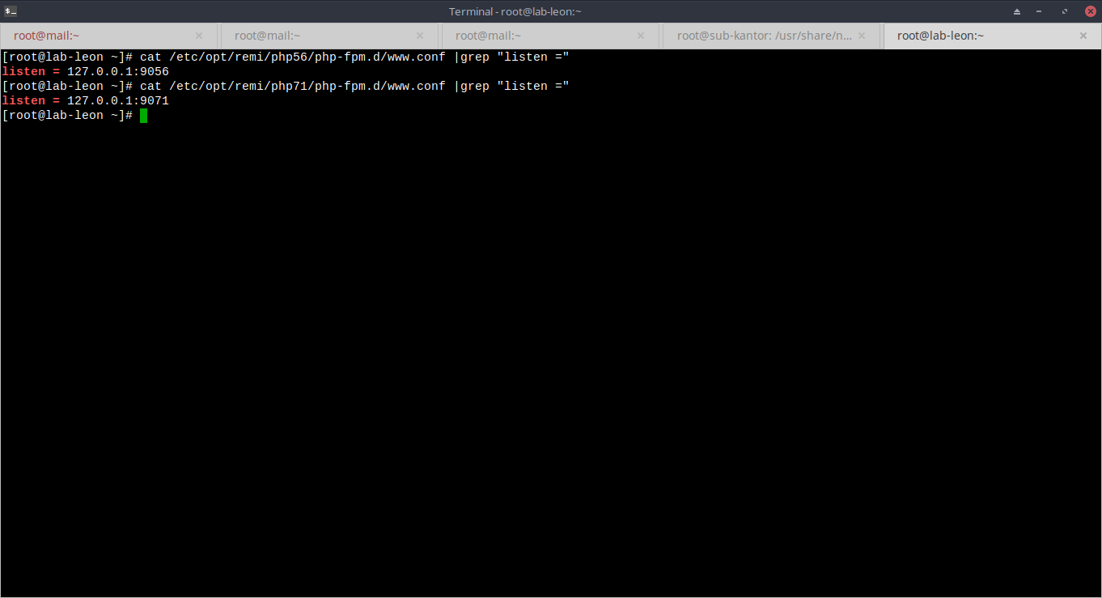
5. konfigurasi php fcgi
cat > /var/www/cgi-bin/php56.fcgi << EOF
#!/bin/bash
exec /bin/php56-cgi
EOF
sudo chmod 755 /var/www/cgi-bin/php56.fcgi
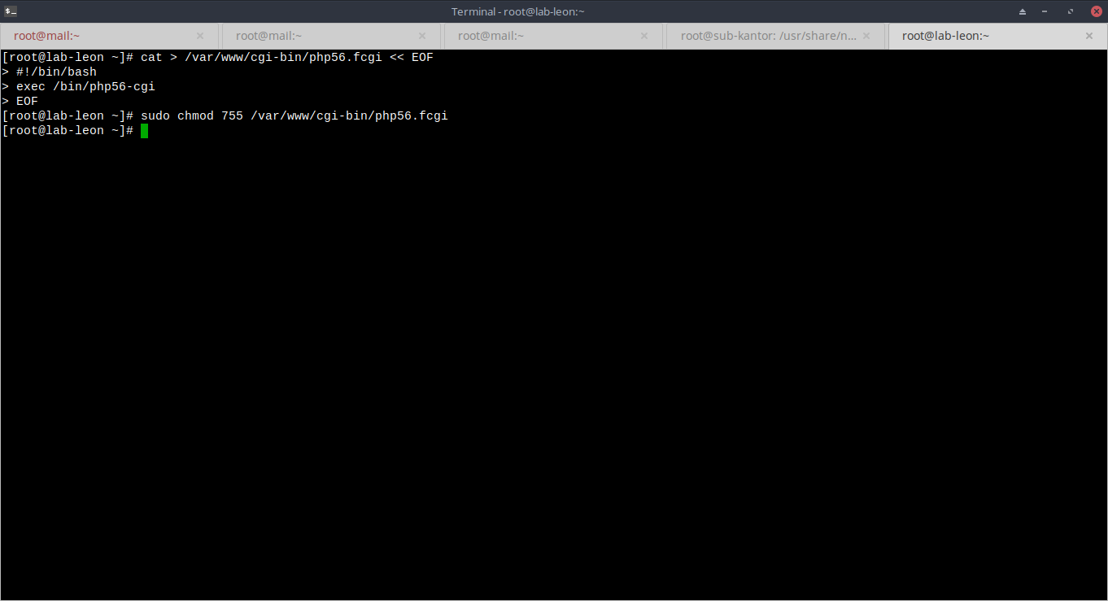
cat > /var/www/cgi-bin/php71.fcgi << EOF
#!/bin/bash
exec /bin/php71-cgi
EOF
sudo chmod 755 /var/www/cgi-bin/php71.fcgi
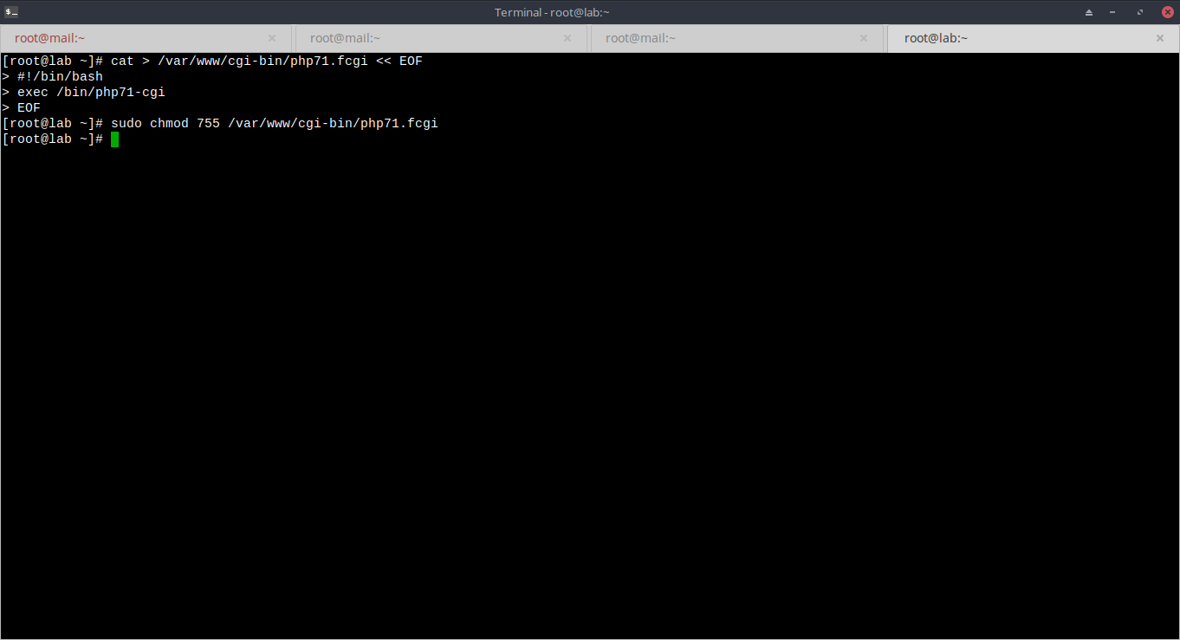
6. tambahkan handler untuk php fpm pada file httpd.conf
vim /etc/httpd/conf.d/php.conf
...............
Action php56-fcgi /cgi-bin/php56.fcgi
<Directory /var/www/html/client1>
DirectoryIndex index.php
AllowOverride all
SetHandler "proxy:fcgi://127.0.0.1:9056"
Require all granted
</Directory>
..................

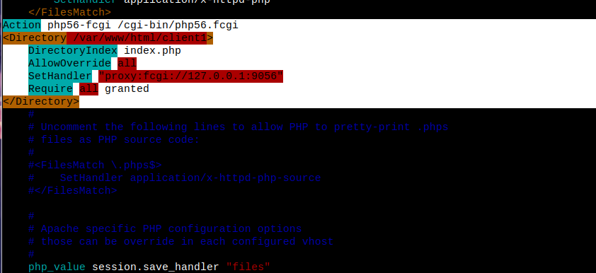
7. Comment config pada php.conf
vim /etc/http/conf.d/php.conf
………………..
<IfModule mod_php7.c>
#
# Cause the PHP interpreter to handle files with a .php extension.
#
#<FilesMatch \.php$>
# SetHandler application/x-httpd-php
#</FilesMatch>
Action php56-fcgi /cgi-bin/php56.fcgi
<Directory /var/www/html/client1>
…………….
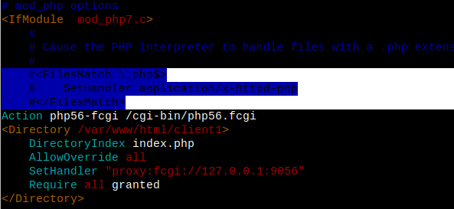
8. buat dir client1 dan client2
mkdir /var/www/html/client1
mkdir /var/www/html/client2
chmod -R 755 /var/www/html/client1 && chown -R apache:apache /var/www/html/client1
chmod 755 /var/www/html/client2 && chown -R apache:apache /var/www/html/client1

9. Buat dir sites-available & sites-enabled
mkdir /etc/httpd/sites-available
mkdir /etc/httpd/sites-enabled
echo "IncludeOptional sites-enabled/*.conf" >> /etc/httpd/conf/httpd.conf

10. buat virtualhost untuk client1
vim /etc/httpd/sites-available/client1.leon36.web.id.co nf
.............
<VirtualHost *:80>
ServerAdmin admin@leon36.web.id
ServerName www.client1.leon36.web.id
ServerAlias client1.leon36.web.id
DocumentRoot /var/www/html/client1
<Directory /var/www/html/client1>
Options FollowSymLinks
AllowOverride All
Require all granted
</Directory>
ErrorLog /var/log/httpd/client1.leon36.web.id_error.log
CustomLog /var/log/httpd/client1.leon36.web.id_access.log combined
</VirtualHost>
………….
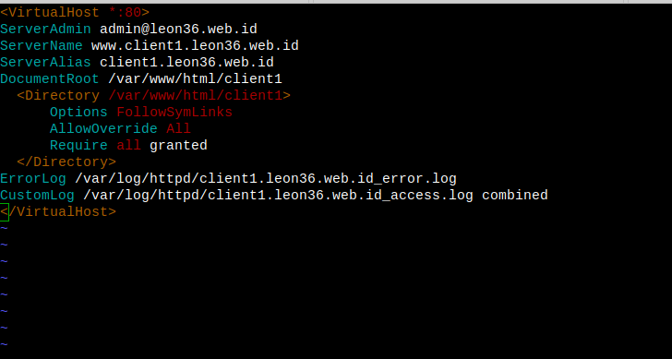
11. buat virtualhost untuk client2
vim /etc/httpd/sites-available/client2.leon36.web.id.co nf
…………………
<VirtualHost *:80>
ServerAdmin admin@leon36.web.id
ServerName www.client2.leon36.web.id
ServerAlias client2.leon36.web.id
DocumentRoot /var/www/html/client2
<Directory /var/www/html/client2>
<FilesMatch \.(php|phar)$>
SetHandler application/x-httpd-php
</FilesMatch>
Options FollowSymLinks
AllowOverride All
Require all granted
</Directory>
ErrorLog /var/log/httpd/client2.leon36.web.id_error.log
CustomLog /var/log/httpd/client2.leon36.web.id_access.log combined
</VirtualHost>
……………….
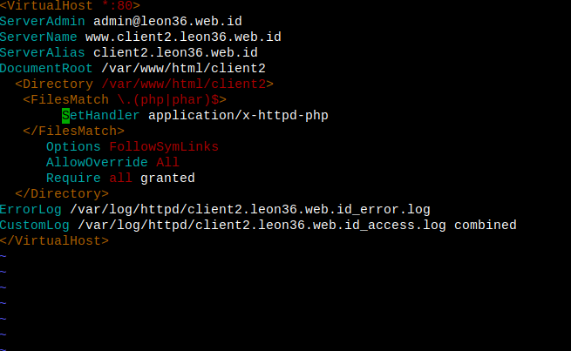
12. Buat symlink file virtualhost client1 & 2 ke dir sites-enabled
ln -s /etc/httpd/sites-available/client1.leon3 6.web.id.conf /etc/httpd/sites-enabled/client1.leon36.web.id.conf
ln -s /etc/httpd/sites-available/client2.leon3 6.web.id.conf /etc/httpd/sites-enabled/client2.leon36.web.id.conf
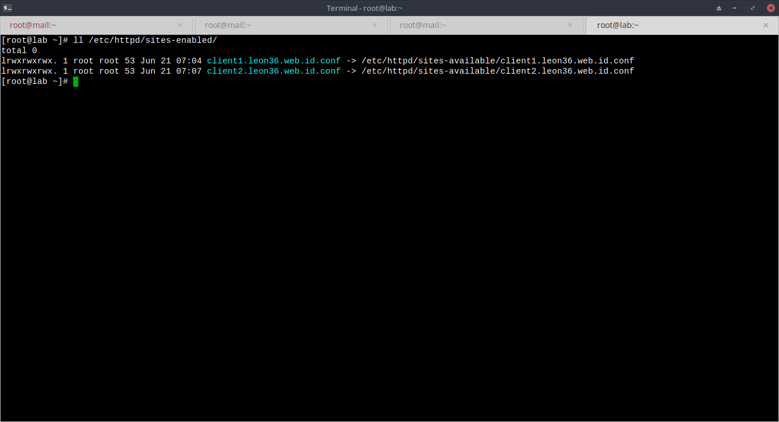
13. buat file info.php pada semua client.leon36 untuk verifikasi versi php pada virtual host
echo "<?php phpinfo(); ?>" >> /var/www/html/client1/ info.php
echo "<?php phpinfo(); ?>" >> /var/www/html/client2/ info.php

14. pastikan versi PHP sudah berbeda
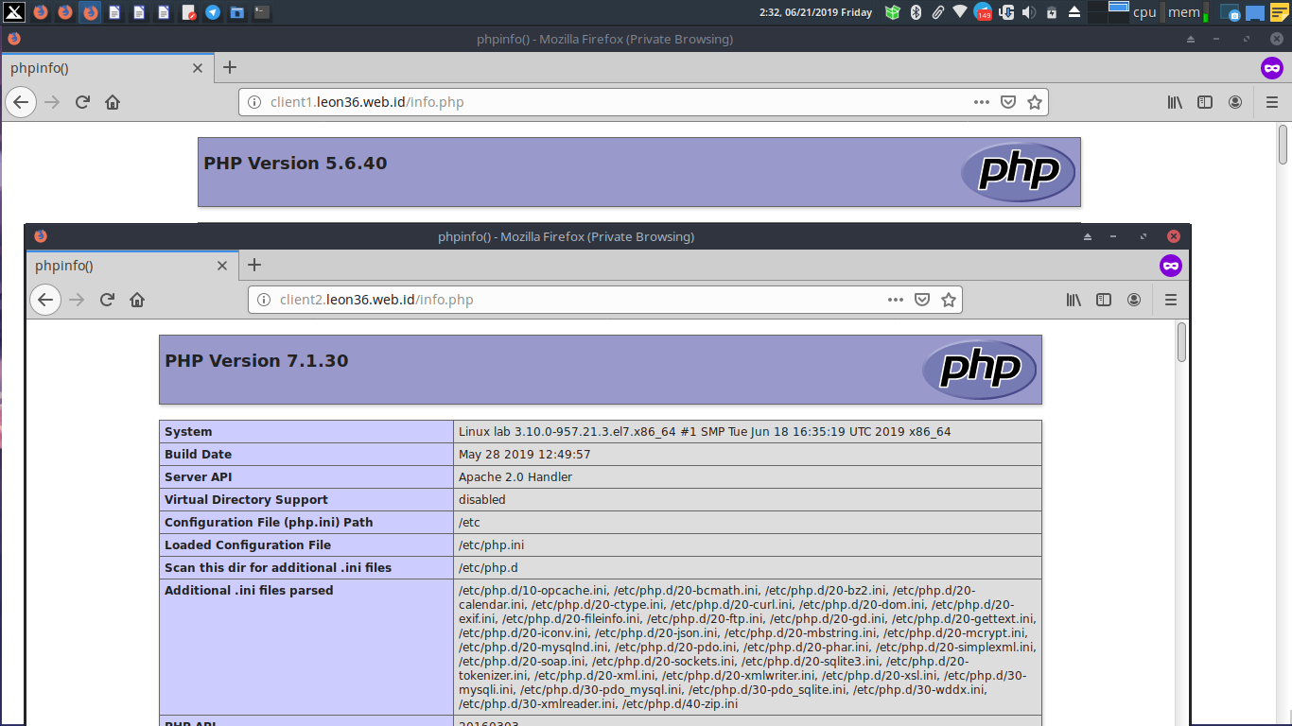
15. tambahkan repo mariadb
vim /etc/yum.repos.d/mariadb.repo
........
[mariadb]
name = MariaDB
baseurl = http://yum.mariadb.org/10.1/centos7-amd64
gpgkey=https://yum.mariadb.org/RPM-GPG-KEY-MariaDB
gpgcheck=1
........

16. install mariadb
yum update -y
yum install -y mariadb-server
systemctl start mariadb && systemctl enable mariadb
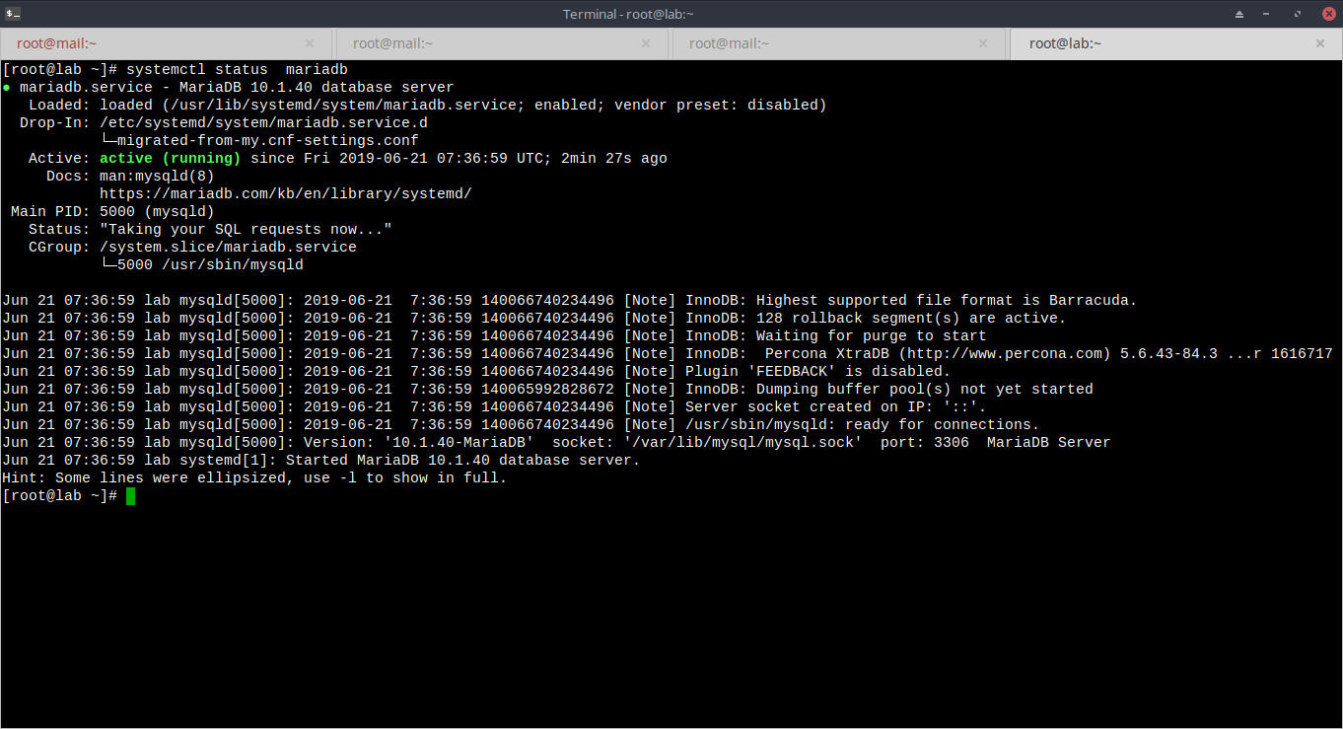
17. lakukan secure install pada mariadb
mysql_secure_installation
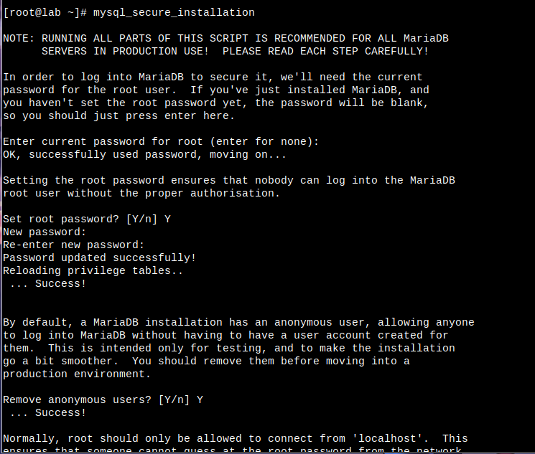

18. download wordpress
wget -c http://wordpress.org/latest.tar.gz
tar xvfz latest.tar.gz -C client1
mv wordpress client1
mv client1 /var/www/html/
chmod -R 755 /var/www/html/client1
chown -R apache:apache /var/www/html/client1

19. konfigurasi database untuk wordpress
mysql -u root -p
CREATE DATABASE wordpress_db;
GRANT ALL PRIVILEGES ON wordpress_db.* TO 'wpuser'@'localhost' IDENTIFIED BY 'qwaA23cca';
FLUSH PRIVILEGES;
show databases;
exit;

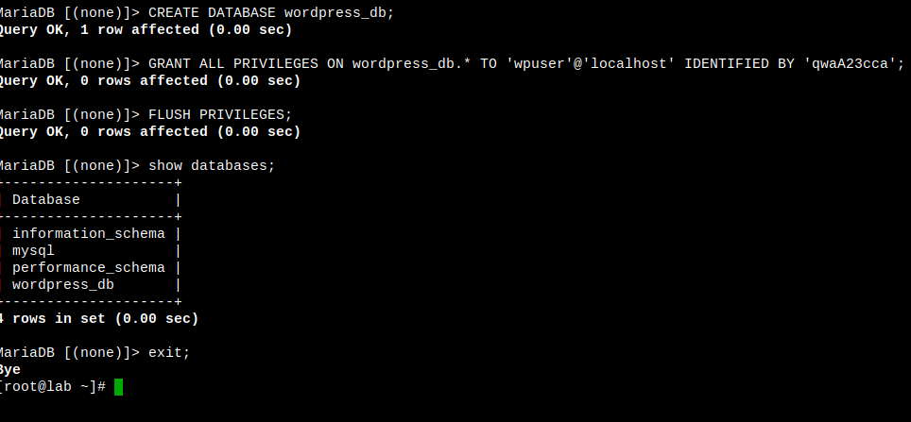
20. Modifikasi file config wordpress
cd /var/www/html/client1
cp wp-config-sample.php wp-config.php
vim wp-config.php
...........
define('DB_NAME', 'wordpress_db');
define('DB_USER', 'wpuser');
define('DB_PASSWORD', 'qwaA23cca');
.........…
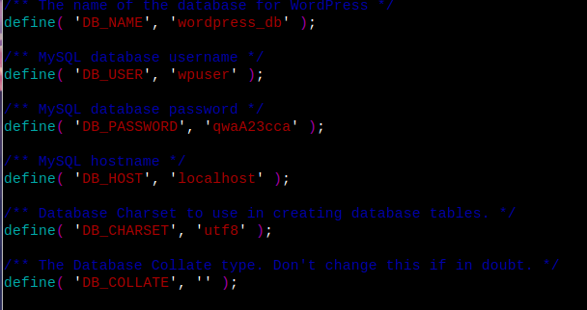
21. restart service apache
systemctl restart httpd

22. install wordpress
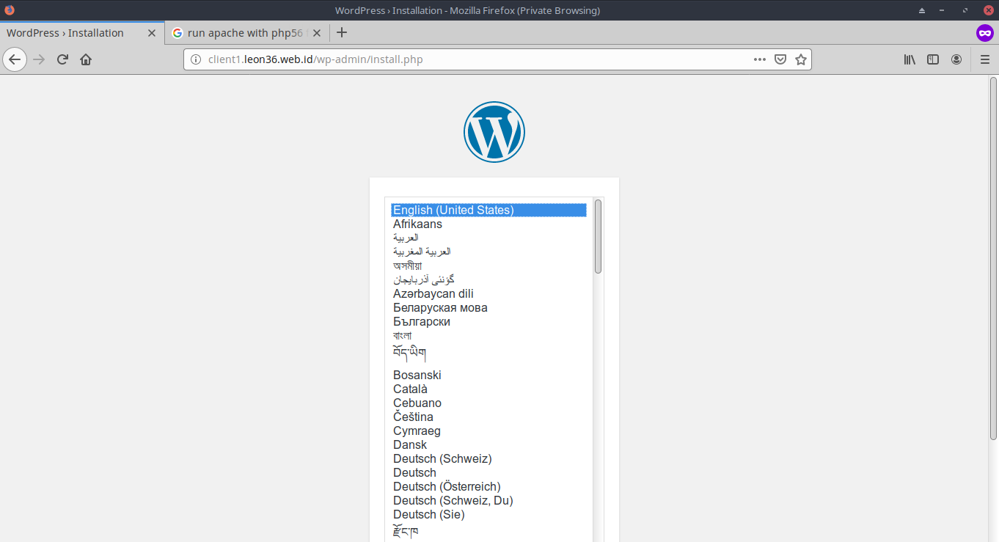
23. Selesai
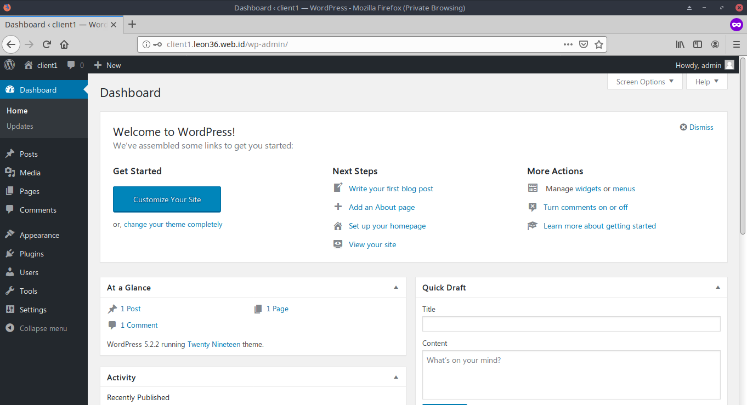

23. Tambahkan database untuk joomla
mysql -u root
CREATE DATABASE joomla_db;
GRANT ALL PRIVILEGES ON joomla_db.* TO 'joomlauser'@'localhost' IDENTIFIED BY 'seaWsa2D';
FLUSH PRIVILEGES;
show databases;
exit;

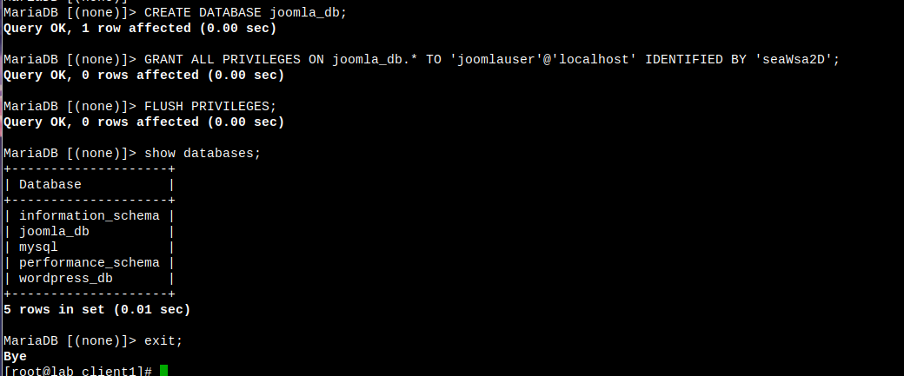
24. Download Joomla
wget https://downloads.joomla.org/cms/joomla3/3-9-8 /Joomla_3-9-8-Stable-Full_Package.tar.gz?format=gz
mv Joomla_3-9-8-Stable-Full_Package.tar.gz?format=gz /var/www/html/client2/Joomla_3-9-8-Stable-Full_Package.tar.gz
cd /var/www/html/client2
tar xfvz Joomla_3-9-8-Stable-Full_Package.tar.gz
chown -R apache:apache /var/www/html/client2
chmod -R 755 /var/www/html/client2

25. Install Joomla
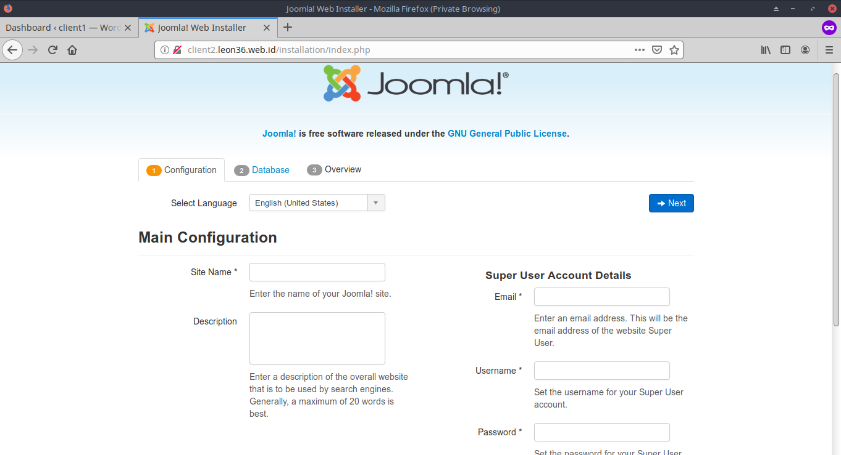

26. Selesai
